1. Overriding the default commands:
2. Listing Running Container:
3. Creating and Starting container
4. Restarting a Stopped Container:
5. Removing Stopped Container
6. Retrieving Log Outputs
7. Stopping Container
8. Multi-command container
9. It
10. Getting_a_Command_Prompt_in_a_Container
11. Creating Docker Image
12. Tagging an image when creating it.
13. How to create an Image out of a running container
14. Top
15. Bottom

1. Overriding the default commands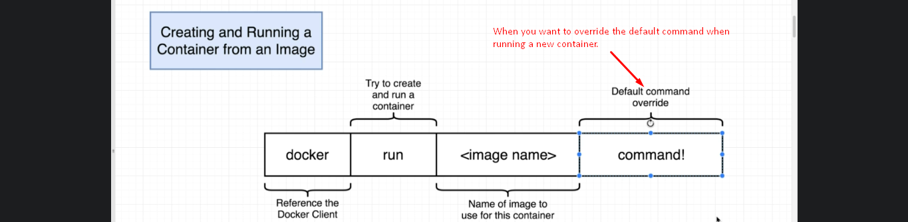  
     
   
2. **Listing Running Container** --all : to list existed and running containers.
3. Creating and Starting a container:  
   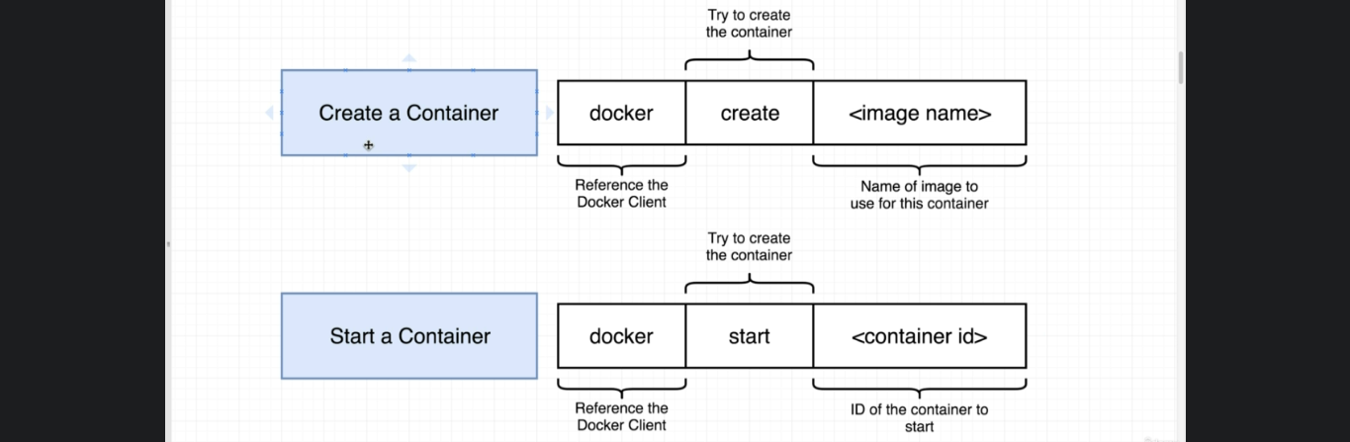docker start –a <container-id>  
   -a : To attach the console to the container’s output.
4. Restarting Stopped Container  
   docker start <container-id>
5. Removing Stopped Container:  
   Docker system prune
6. Retrieving Log Outputs:  
   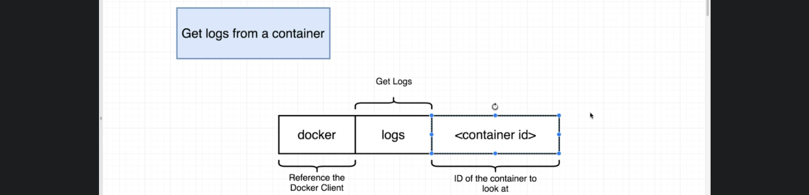This command will not create nor start a container but will spit the previous logs from the already run container.

Stopping Container

1. 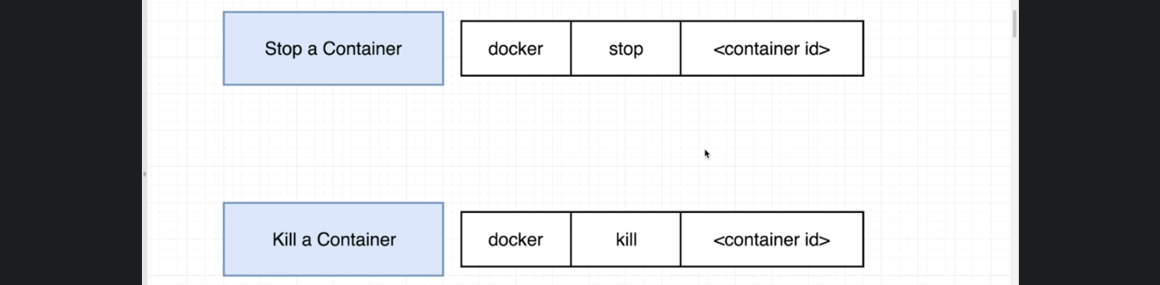  
     
   

Multi-Command Container

1. 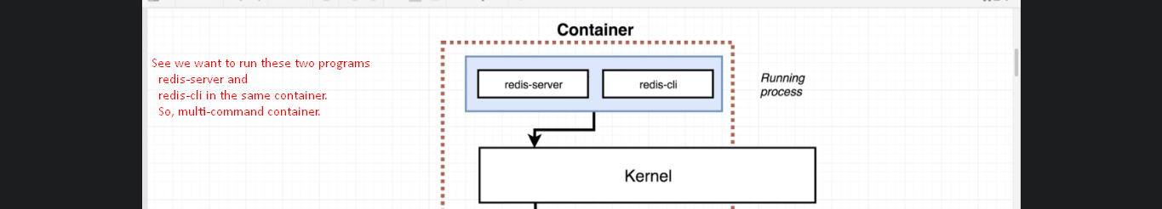
2. 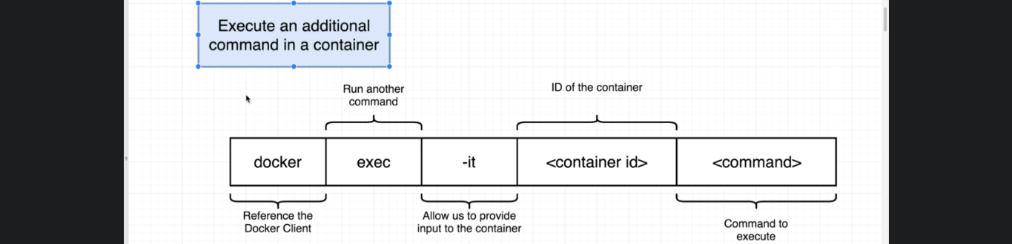

-it

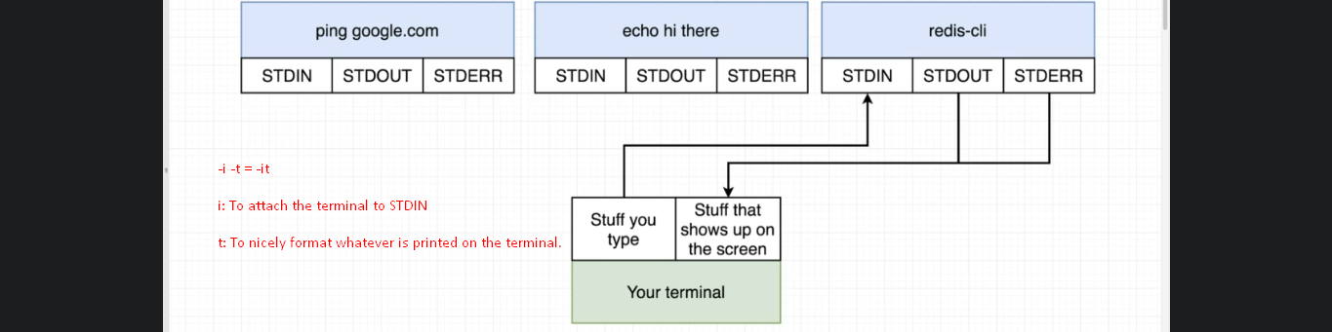

Getting a Command Prompt in a Container

1. 

Creating Docker Images

 

Tagging an image when creating it

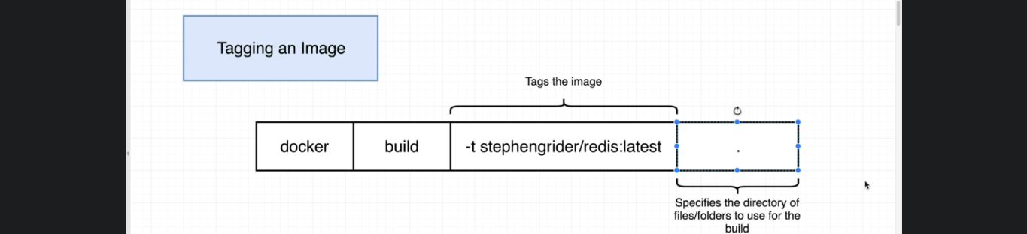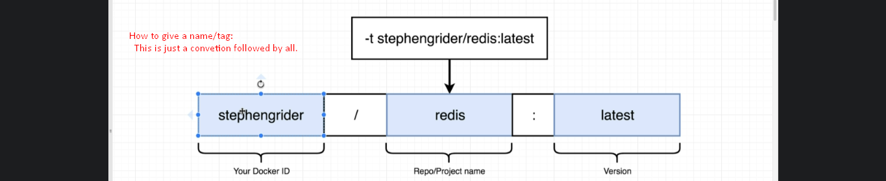 

How to create an Image out of a running container.



TOP

Bottom